Machine Problem 1: Guessing Game
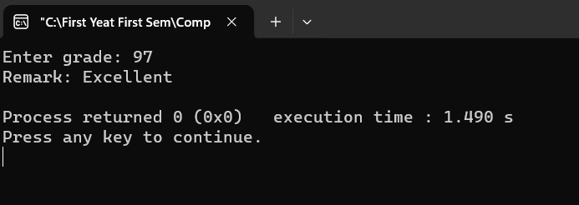
Here is my c++ code:
#include <iostream>
using namespace std;

int main() {
int target = 50;
int num;

start:
cout << "Guessing Game" << endl;
cout << "Enter your guess number: ";
cin >> num;

if (num < target) {
cout << "Your guess is too low. Try again!" << endl;
goto start;
} else if (num > target) {
cout << "Your guess is too high. Try again!" << endl;
goto start;
} else {
cout << "Congratulations! You guessed the correct number!" << endl;
}

return 0;
}

Machine Problem 2: Remark System
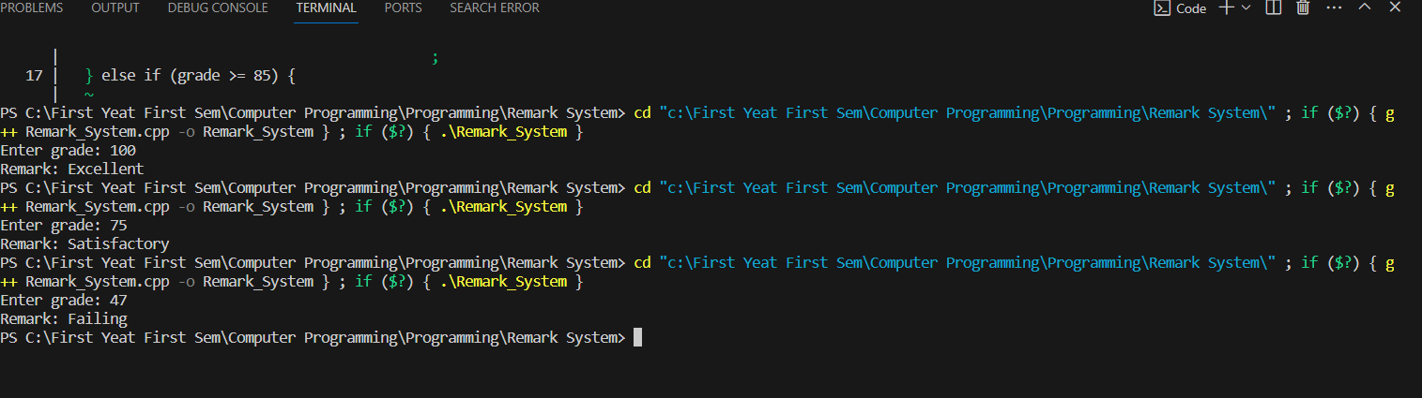
Here is my C++ code:
#include <iostream>

using namespace std;

int main() {
int grade;

cout << "Enter grade: ";
cin >> grade;

if (grade >= 101) {
cout << "Remark: Overflow" << endl;
} else if (grade >= 95) {
cout << "Remark: Excellent" << endl;
} else if (grade >= 90) {
cout << "Remark: Very Good" << endl;
} else if (grade >= 85) {
cout << "Remark: Good" << endl;
} else if (grade >= 75) {
cout << "Remark: Satisfactory" << endl;
} else if (grade >= 70) {
cout << "Remark: Needs Improvement" << endl;
} else if (grade >= 1) {
cout << "Remark: Failing" << endl;
} else {
cout << "Remark: Invalid input" << endl;
}

return 0;
}

Machine Problem 3: Horoscope
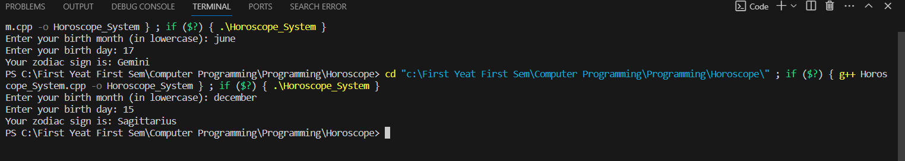
Here is my C++ code:
#include <iostream>
#include <string>

using namespace std;

int main() {

string zodiacSign;
string month;
int day;

cout << "Enter your birth month (in lowercase): ";
cin >> month;

cout << "Enter your birth day: ";
cin >> day;

// Determine the zodiac sign based on the month and day
if (month == "march") {
if (month == "march" && (day >= 21 && day <= 31)) {
zodiacSign = "Aries";
} else {
zodiacSign = "Pisces";
}
} else if (month == "april") {
if (day >= 20) {
zodiacSign = "Taurus";
} else {
zodiacSign = "Aries";
}
} else if (month == "may") {
if (day >= 21) {
zodiacSign = "Gemini";
} else {
zodiacSign = "Taurus";
}
} else if (month == "june") {
if (day >= 21) {
zodiacSign = "Cancer";
} else {
zodiacSign = "Gemini";
}
} else if (month == "july") {
if (day >= 23) {
zodiacSign = "Leo";
} else {
zodiacSign = "Cancer";
}
} else if (month == "august") {
if (day >= 23) {
zodiacSign = "Virgo";
} else {
zodiacSign = "Leo";
}
} else if (month == "september") {
if (day >= 23) {
zodiacSign = "Libra";
} else {
zodiacSign = "Virgo";
}
} else if (month == "october") {
if (day >= 23) {
zodiacSign = "Scorpio";
} else {
zodiacSign = "Libra";
}
} else if (month == "november") {
if (day >= 22) {
zodiacSign = "Sagittarius";
} else {
zodiacSign = "Scorpio";
}
} else if (month == "december") {
if (day >= 22) {
zodiacSign = "Capricorn";
} else {
zodiacSign = "Sagittarius";
}
} else if (month == "january") {
if (day >= 20) {
zodiacSign = "Aquarius";
} else {
zodiacSign = "Capricorn";
}
} else if (month == "february") {
if (day >= 19) {
zodiacSign = "Pisces";
} else {
zodiacSign = "Aquarius";
}
} else {
cout << "Invalid month" << endl;
return 0;
}

// Display the horoscope message
cout << "Your zodiac sign is: " << zodiacSign << endl;

return 0;
}

